Math Game – Assignment – 3

Submitted by Arun Kumar Kanakasabai

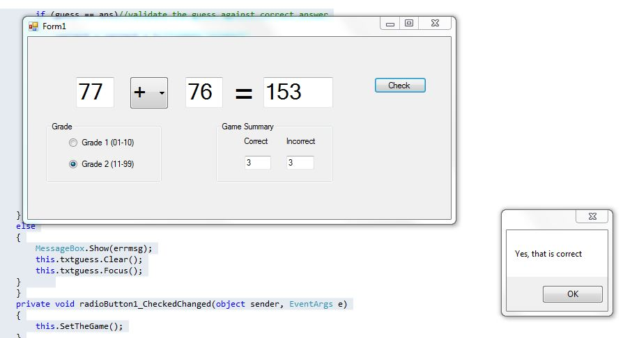

using System;

using System.Collections.Generic;

using System.ComponentModel;

using System.Data;

using System.Drawing;

using System.Linq;

using System.Text;

using System.Windows.Forms;

using System.Text.RegularExpressions;

namespace WindowsFormsApplication1

{

public partial class Form1 : Form

{

Random rand = new Random();//instantiating the random class

int num1, num2, ans, guess;//declaring the variables

string oprn;

int correct = 0; //initialize the counters

int incorrect = 0;

public Form1()

{

InitializeComponent();

}

public void SetTheGame()

{

oprn = this.txtopr.SelectedItem.ToString(); // choosing the operation

if (this.radioButton1.Checked == true)

{

num1 = rand.Next(1,10); //generate the rndom nos.for grade1

num2 = rand.Next(1,10) ;

}

else

{

num1 = rand.Next(10,100); //generate the random nos for grade2

num2 = rand.Next(10,100);

}

if (oprn == "-") //validate minus operation

{

if (num1 < num2)

{

int swapValues;

swapValues = num2;

num2 = num1;

num1 = swapValues;

}

else if (oprn == "/") //validate division operation

{

if (num1 % num2 != 0)

num1 = num2 * 2;

}

}

this.txtnum1.Text = num1.ToString(); //assigning random nos. to textboxes

this.txtnum2.Text = num2.ToString();

}

private void Button1_Click(object sender, EventArgs e)

{

string guessPattern = @"^[0-9]\d*(\d+)?$"; //regular expression validation

string errmsg = "";

if (this.txtguess.Text == "")

{ errmsg = errmsg + "Pls enter your answer"; }

else if (Regex.IsMatch(this.txtguess.Text, guessPattern) == false)

errmsg = errmsg + "Pls enter again";

if (errmsg.Length == 0)

{

num1 = Convert.ToInt32(this.txtnum1.Text);

num2 = Convert.ToInt32(this.txtnum2.Text);

guess = Convert.ToInt32(this.txtguess.Text);

if (oprn == "+")

{ ans = num1 + num2; }

else if (oprn == "-")

{ ans = num1 - num2; }

else if (oprn == "*")

{ ans = num1 * num2; }

else

{ ans = num1 / num2; }

if (guess == ans)//validate the guess against correct answer

{

correct = correct + 1;//update counters

this.txtcorrect.Text = correct.ToString();

MessageBox.Show("Yes, that is correct");

txtguess.Clear();

SetTheGame();

txtguess.Focus();

}

else

{

incorrect = incorrect + 1;

this.txtincorrect.Text = incorrect.ToString();

MessageBox.Show("Sorry, Wrong answer");

txtguess.Clear();

SetTheGame();

txtguess.Focus();

}

}

else

{

MessageBox.Show(errmsg);

this.txtguess.Clear();

this.txtguess.Focus();

}

}

private void radioButton1_CheckedChanged(object sender, EventArgs e)

{

this.SetTheGame();

}

private void radioButton2_CheckedChanged(object sender, EventArgs e)

{

this.SetTheGame();

}

}

}